OBUDA UNIVERSITY
John von Neumann Faculty of Informatics
BSc in Computer Science Engineering | Full-time | Spring 2025/2026

OPERATING SYSTEMS
SEMESTER TASK DOCUMENTATION
Task 3 - Development Environment & Web Service

Technology Stack
Microsoft Azure · Ubuntu Server 24.04 LTS · Gitea 1.22 · Nginx · dnsmasq
Python Flask · Netdata · rsync + cron · VMware Workstation Pro · VS Code · Git CLI

Authors: | Rehan Khaliq (EPA5RI) rehankhaliq@stud.uni-obuda.hu
 | Shah Nawaz (GEWXHI) shahnawaz@stud.uni-obuda.hu
 | Danial Umer (FTBE2V) danialumer@stud.uni-obuda.hu
Institution: | Obuda University, John von Neumann Faculty of Informatics
Field of Study: | BSc in Computer Science Engineering
Program: | Full-time
Semester: | Spring 2025/2026
Task Code: | 3 - Development Environment and Web Service
Submission Date: | Spring 2026

Table of Contents
1 Specification
1.1 Task Description
1.2 Stakeholders and Use Cases
1.3 Requirements
2 Planning
2.1 Software Selection
2.2 System Architecture and Design
2.3 Network Plan
2.4 Server Plan
2.5 Client Plan
2.6 Test Plan
3 Implementation
3.1 Cloud Infrastructure Provisioning
3.2 Server Baseline Configuration
3.3 Gitea (Version Control System)
3.4 Nginx (Web Server and Reverse Proxy)
3.5 TLS Certificate (HTTPS)
3.6 Corporate Website
3.7 Flask Web Application
3.8 dnsmasq (Internal DNS)
3.9 Netdata (Monitoring)
3.10 Backup Automation
3.11 Client Virtual Machines
4 Testing
4.1 Version Control Tests
4.2 Web Service Tests
4.3 Server Access Tests
4.4 Client Tests
4.5 Backup Tests

1. Specification

1.1 Task Description
DevLab Technologies approached our engineering consultancy in early 2026 with a critical business challenge that had been constraining their growth for over eighteen months. As a rapidly expanding software development organization specializing in custom enterprise solutions, DevLab had experienced significant success in securing major client contracts across multiple industry verticals. However, their continued reliance on a fragmented collection of third-party cloud services and external development platforms had created operational vulnerabilities that were increasingly impacting their ability to deliver projects on schedule and maintain the high security standards demanded by their enterprise clients.
The engagement began when DevLab's executive leadership team, led by their Chief Technology Officer Sarah Chen and Head of Operations Michael Rodriguez, presented us with a comprehensive assessment of their current infrastructure challenges. Their development teams were distributed across multiple third-party platforms including GitHub Enterprise, Atlassian Cloud, and various project management tools, creating data silos and workflow inefficiencies. More critically, several high-profile clients had raised concerns about intellectual property security, specifically questioning why DevLab's proprietary code repositories were hosted on external platforms rather than on infrastructure under DevLab's direct administrative control. These concerns had already resulted in the loss of two potential contracts worth over $2.3 million in combined revenue.
The situation became urgent following a service outage at one of their primary cloud providers that lasted fourteen hours and prevented their entire development team from accessing critical project repositories during a crucial client delivery milestone. This incident exposed the fundamental risk of vendor dependency and prompted DevLab's board of directors to mandate a comprehensive review of their development infrastructure strategy. Additionally, their legal department had identified compliance risks related to data sovereignty requirements from European clients operating under GDPR regulations, as well as growing concerns from government sector prospects about the security implications of hosting sensitive project data on shared cloud platforms.
DevLab's leadership outlined an ambitious vision for a completely self-administered development environment that would eliminate their dependence on external service providers while maintaining all the collaborative capabilities their distributed team required. The solution needed to support their current team of forty-seven developers working across six different time zones, with the scalability to accommodate their projected growth to over eighty team members within the next two years. The platform had to integrate seamlessly with their existing client delivery workflows while providing the robust security controls and audit trails required by their enterprise customers in the financial services and healthcare sectors.
Our team was tasked with designing and implementing a comprehensive development platform that would consolidate version control, issue tracking, project management, continuous integration, and client communication tools into a unified, self-hosted environment. The system needed to support multiple concurrent projects with strict access controls and complete audit logging of all development activities. Furthermore, DevLab requested the integration of a professional client-facing web presence that would demonstrate their technical capabilities while serving as a showcase for the custom web applications they developed for their clients. The entire solution had to be production-ready from day one, with built-in redundancy, automated backup systems, and monitoring capabilities that would allow their internal IT team to maintain the platform without requiring specialized external support.
Beyond the technical requirements, DevLab's leadership emphasized the strategic importance of this initiative in positioning their company as a technology leader capable of managing complex infrastructure challenges. They planned to leverage this self-hosted development platform as a competitive differentiator in client proposals, demonstrating their commitment to security and operational excellence. The project also needed to serve as a proof-of-concept for similar infrastructure solutions they intended to offer as managed services to their own clients, creating a potential new revenue stream estimated at $1.8 million annually within three years. This dual purpose meant that every aspect of the implementation had to meet enterprise-grade standards for reliability, security, and performance, as it would ultimately serve as a reference architecture for client engagements.

Property | Value
Team Size | 3 Developers / Operators
Server Hosting | Microsoft Azure
Server VM Size | Standard_B2s_v2 (2 vCPU, 8 GB RAM, 30 GB SSD)
Server OS | Ubuntu Server 24.04 LTS
Client VMs | VMware Workstation Pro on developer laptops
Public IP Address | 20.215.214.197 (Static)
Internal Domain | devlab.local
Total Licence Cost | EUR 0 (Azure for Students plus open-source software)
Table 1.1 - Project overview

1.2 Stakeholders and Use Cases
Five stakeholder groups interact with the platform. Each has clearly defined responsibilities and a distinct set of interactions that drive the functional and security requirements documented in section 1.3.

Actor | Description | System Interactions
Developer | Writes, commits and manages source code for active projects. | Git push and pull via CLI; Gitea web UI; issue tracker; branch management; code review via pull requests.
IT Operator | Maintains the VM, services, configuration and security posture of the platform. | SSH remote access; Netdata dashboard; Gitea user management; backup verification; service restarts.
Project Manager | Oversees project milestones, task assignment, and progress tracking. | Gitea issue tracker; repository browsing; Netdata read-only view; website review.
Website Visitor | External user browsing the DevLab corporate website. | HTTPS access to corporate website and unit-converter application; no authentication required.
System Administrator | Manages cloud infrastructure, firewall rules, and VM lifecycle. | Azure portal; NSG firewall rules; VM snapshots; resource allocation; SSH key management.
Table 1.2 - Stakeholder groups and their system interactions

1.3 Requirements

1.3.1 Server-Side Functional Requirements
ID | Component | Requirement
SRV-01 | Version Control | Self-hosted Gitea with admin-only account creation; public self-registration permanently disabled.
SRV-02 | Version Control | Integrated issue and bug tracker per repository with role-based access (Owner / Writer / Reader).
SRV-03 | Web Server | Nginx serves the corporate website over HTTP (port 80) and HTTPS (port 443).
SRV-04 | Reverse Proxy | Nginx proxies the Gitea web UI and the Netdata dashboard on clean URLs.
SRV-05 | DNS | dnsmasq resolves all internal hostnames under the devlab.local domain.
SRV-06 | Backup | Nightly rsync backup of Gitea data and website files to a separate directory.
SRV-07 | Remote Access | SSH on port 22 with RSA public-key authentication; password login disabled at OS level.
SRV-08 | Monitoring | Netdata monitors CPU, RAM, disk and network; web dashboard exposed on port 19999.
SRV-09 | Web Application | Python Flask application accepts user input, performs server-side computation, returns the result.
SRV-10 | HTTPS | TLS certificate installed; HTTP automatically redirects to HTTPS.
Table 1.3 - Server-side functional requirements

1.3.2 Client-Side Functional Requirements
ID | Component | Requirement
CLI-01 | Client VM 1 | Windows 11 Education as primary developer workstation, deployed in VMware Workstation Pro.
CLI-02 | Client VM 2 | Ubuntu Desktop 24.04 as a second client VM for cross-platform Git compatibility.
CLI-03 | Git Client | Git CLI installed and configured on both client VMs.
CLI-04 | IDE | VS Code with Git integration installed on both clients.
CLI-05 | Push / Pull | Client 1 pushes code to the development branch; Client 2 pulls from the development branch.
Table 1.4 - Client-side functional requirements

1.3.3 Network Requirements
ID | Requirement
NET-01 | Gitea is accessible from the public internet via the static public IP 20.215.214.197 on TCP port 3000.
NET-02 | Corporate website is accessible on TCP 80 (redirecting) and TCP 443 (HTTPS) from both internet and LAN.
NET-03 | Internal DNS resolves all devlab.local hostnames via dnsmasq on port 53.
NET-04 | Azure NSG enforces a default-deny inbound policy; only explicitly whitelisted ports are open.
NET-05 | SSH (port 22) requires public-key authentication; password authentication is disabled at the OS level.
NET-06 | Netdata dashboard (port 19999) is accessible from authorised client browsers.
NET-07 | Flask web application is served via the Nginx reverse proxy; port 5000 is not directly exposed to the internet.
NET-08 | Client VMs run on the VMware NAT network and reach the Azure server via its public IP.
Table 1.5 - Network requirements

1.3.4 Security Requirements
ID | Requirement
SEC-01 | Gitea self-registration is permanently disabled; all accounts are created exclusively by the gitadmin role.
SEC-02 | SSH PasswordAuthentication is set to 'no' in /etc/ssh/sshd_config; enforced at the OS level.
SEC-03 | Nginx serves HTTPS with a self-signed TLS certificate; HTTP (port 80) auto-redirects to HTTPS (port 443).
SEC-04 | Backup data is stored under /mnt/backup/, on a path separate from the primary /var/lib/gitea/ data path.
SEC-05 | UFW is active on Ubuntu Server with a default-deny inbound policy; only the required ports are whitelisted.
SEC-06 | Azure NSG provides a second firewall layer; both UFW and NSG must permit traffic for it to reach a service.
SEC-07 | SSH access is restricted to authorised public-key holders; no shared passwords are issued.
Table 1.6 - Security requirements

1.3.5 Other Requirements
ID | Requirement
OTH-01 | All server software must be open-source and zero-cost; a Linux operating system is preferred for the server.
OTH-02 | The system must support three concurrent developer sessions without performance degradation.
OTH-03 | All infrastructure is to be managed via the Azure Portal, SSH, and VMware Workstation Pro.
OTH-04 | The backup script must write a timestamped log entry covering start, status, and completion on every execution.
OTH-05 | Full documentation must cover specification, planning, implementation, and testing with supporting evidence.
OTH-06 | The second client VM runs a different operating system (Linux) for cross-platform validation.
Table 1.7 - Other requirements

2. Planning

2.1 Software Selection
Each software component was evaluated against four criteria: functional fit for the requirements; resource efficiency on a constrained cloud VM; licence cost (target: zero); and ease of configuration and maintenance. Open-source solutions with strong community support and documented production use were preferred throughout.

2.1.1 Version Control System
Software | Advantages | Disadvantages | Cost
Gitea (Selected) | Lightweight memory and CPU footprint. Full Git workflow support. Integrated issue tracker. Admin-controlled registration. MIT licence. Active community. Familiar GitHub-style UI. | Less recognised than GitLab in enterprise settings. Gitea Actions CI/CD is a relatively new feature. | Free
GitLab CE | Feature-rich, with built-in CI/CD pipelines, strong merge-request workflows, and an industry-standard reputation. | Requires a minimum of 4 GB RAM, which would consume the entire VM budget on its own. Complex setup. Overkill for a 3-person team. | Free
GitHub.com | Most widely known platform, excellent third-party integrations, familiar interface. | Cloud-hosted, which violates the on-premise sovereignty requirement of the project. Private repositories require a paid plan. | Paid
Gogs | Extremely lightweight, simple setup, minimal resource usage. | Limited issue-tracker functionality. Slow development cadence. Missing several features required by the project. | Free
Table 2.1 - Version control system comparison
Selected: Gitea. Lightweight, fully self-hosted Git platform with integrated issue tracking, admin-only registration, and zero licence cost. A clean fit for a 3-person team running on a single Ubuntu Server VM, distributed under the MIT licence.

2.1.2 Server Operating System
OS | Advantages | Disadvantages | Cost
Ubuntu Server 24.04 LTS (Selected) | Free, with a 5-year LTS support window through 2029. Large apt package ecosystem. All chosen services are natively supported and well-documented. Industry standard for DevOps deployments. | Requires Linux command-line knowledge. No GUI by design. | Free
Debian 12 Bookworm | Free, extremely stable, minimal resource usage, excellent long-term support. | Slightly older package versions. Less beginner-friendly documentation. | Free
Windows Server 2022 | GUI-based management, familiar to Windows administrators. | High licence cost. Higher VM resource overhead. Gitea and dnsmasq are less natural to operate on Windows Server. | EUR 600+
Table 2.2 - Server operating system comparison
Selected: Ubuntu Server 24.04 LTS. Free, 5-year LTS support, native compatibility with every chosen service, and the de-facto industry standard for Linux-based DevOps environments.

2.1.3 Cloud Infrastructure
Provider | Advantages | Disadvantages | Cost
Microsoft Azure (Selected) | Azure for Students provides USD 100 in free credit with a university email and no credit card required. Global infrastructure. Standard_B2s_v2 size offers 8 GB RAM at the entry tier. | Student subscription restricts available regions and VM sizes. Public IP must be explicitly configured as static. | Free (student)
Hetzner Cloud | Very affordable, Germany / Finland data-centre locations, used by real production workloads, simple interface. | No student free tier; costs EUR 4 to 7 per month from day one. | EUR 4+/mo
Oracle Cloud Free Tier | 24 GB RAM always-free tier with no expiry. | ARM architecture can cause compatibility issues. Complex initial setup and account approval process. | Free
Local VMware only | No internet dependency, full control, fastest network performance for local clients. | No remote access for distributed team members. Depends entirely on a single laptop being powered on. IP changes on every network move. | Free
Table 2.3 - Cloud infrastructure comparison
Selected: Microsoft Azure for Students. USD 100 of free credit, global access for all team members, a static public IP, and the Standard_B2s_v2 VM (2 vCPU, 8 GB RAM).

2.1.4 Web Server
Software | Advantages | Disadvantages | Cost
Nginx (Selected) | Extremely fast static-file serving. Minimal idle memory (around 5 MB). Industry-standard reverse proxy. Clean, readable configuration. HTTPS configurable in minutes via OpenSSL. | Configuration syntax can be unintuitive for a first-time administrator. | Free
Apache HTTP Server | Extremely well-documented, .htaccess per-directory configuration, battle-tested and mature. | Higher memory usage than Nginx. Slower at serving static files under concurrent load. | Free
Caddy | Automatic HTTPS via Let's Encrypt out of the box. Very simple Caddyfile syntax. | Newer project with a smaller community. Fewer professional production references available. | Free
Table 2.4 - Web server comparison

2.1.5 DNS Service
Software | Advantages | Disadvantages | Cost
dnsmasq (Selected) | Purpose-built for small LAN DNS. Total configuration is 5 to 10 lines. Very low memory footprint. Ships in standard Ubuntu apt repositories. Can also serve DHCP if needed. | Not suitable for large enterprise networks. No graphical management interface. | Free
BIND9 | Full RFC-compliant DNS server used by ISPs and large enterprises. Highly configurable zone management. | Complex zone-file configuration. Significant overkill for resolving four hostnames on a small LAN. | Free
Unbound | Security-focused recursive resolver. Lightweight and well-maintained. | More complex to set up than dnsmasq for simple LAN use. No built-in DHCP combination. | Free
Table 2.5 - DNS service comparison

2.1.6 Monitoring Solution
Software | Advantages | Disadvantages | Cost
Netdata (Selected) | Single apt-command installation. Zero configuration required. Real-time web dashboard with one-second granularity. Auto-detects CPU, RAM, disk I/O and network throughput. Roughly 50 MB of RAM usage. | Cloud account required for advanced features and historical retention beyond one hour. | Free
Prometheus + Grafana | Industry standard, highly configurable dashboards, extensible with exporters for any metric. | Three or more components to install and maintain. 500 MB+ combined RAM usage. Steep configuration learning curve. | Free
Zabbix | Enterprise-grade monitoring, SNMP and agent support, comprehensive alerting. | Complex database setup required (MySQL or PostgreSQL). Heavy resource usage. Excessive for a single server. | Free
Table 2.6 - Monitoring solution comparison

2.1.7 Backup Solution
Tool | Advantages | Disadvantages | Cost
rsync + cron (Selected) | rsync has been trusted in production since 1996. Incremental transfers copy only changed files. cron schedules execution at exactly 23:00 nightly. Two-line script, easy to audit and verify. No additional installation required. | Command-line only, no GUI. No built-in encryption (acceptable for a local backup target). | Free (built-in)
BorgBackup | Deduplication saves significant disk space. Built-in AES-256 encryption for backup data. | New syntax to learn. More complex restoration process for individual files. | Free
Veeam Agent for Linux | GUI available. Free Linux agent. Snapshot-consistent backups. | Designed for full-system image backups. Feature-limited in the free tier. | Free (limited)
Table 2.7 - Backup solution comparison

2.1.8 Web Application Framework
Framework | Advantages | Disadvantages | Cost
Python Flask (Selected) | Minimal, easy-to-read code. Native JSON support. Tiny memory footprint. Trivial integration with Nginx via a reverse proxy. Wide community support. | Single-threaded by default; not optimised for very high request rates. | Free (BSD)
Node.js + Express | Large ecosystem of npm packages. Asynchronous request handling. | Heavier baseline footprint than Flask for a small project. JavaScript on the server adds toolchain complexity. | Free
PHP + Apache | Very widely deployed for traditional web applications. | Older programming model, less suited for modern JSON APIs without additional frameworks. | Free
Table 2.8 - Web application framework comparison

2.1.9 Selected Technology Stack Summary
Layer | Component | Selected Software | Version | Licence
Cloud | Virtual Machine Host | Microsoft Azure Standard_B2s_v2 | VM Gen 2 | Free (student)
Infrastructure | Firewall / NSG | Azure Network Security Group + UFW | Built-in | Free
Server | Operating System | Ubuntu Server 24.04 LTS | 24.04 | Free
Server | Version Control + Issues | Gitea | 1.22.3 | Free (MIT)
Server | Web Server + Reverse Proxy | Nginx | 1.24+ | Free
Server | Internal DNS | dnsmasq | 2.89+ | Free
Server | Monitoring Dashboard | Netdata | Latest | Free
Server | Automated Backup | rsync + cron | Built-in | Free
Server | Web Application | Python Flask | 3.x | Free (BSD)
Server | TLS Certificate | OpenSSL Self-signed | RSA 2048 | Free
Client 1 | Developer Workstation OS | Windows 11 Education | 24H2 | Free (university)
Client 2 | Developer Workstation OS | Ubuntu Desktop 24.04 | 24.04 | Free
Both Clients | Hypervisor | VMware Workstation Pro | Latest | Free (personal)
Both Clients | IDE | Visual Studio Code | Latest | Free
Both Clients | Git Client | Git CLI | 2.51 / 2.43 | Free
Table 2.9 - Complete selected technology stack

2.2 System Architecture and Design
The DevLab platform follows a three-tier architecture: cloud infrastructure as the foundation, a hardened Ubuntu Server hosting all application services in the middle tier, and VMware-based developer client VMs at the top tier. The diagrams below describe the deployment from multiple perspectives.

Figure 2.1 - High-Level System Architecture
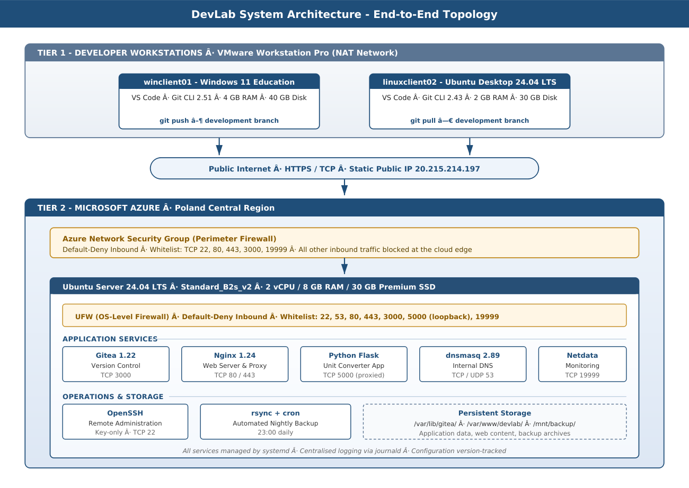
Figure 2.1 - High-level deployment view across the developer workstations, the public internet, and the Azure-hosted server.
Figure 2.2 - Four-Layer Architecture Model
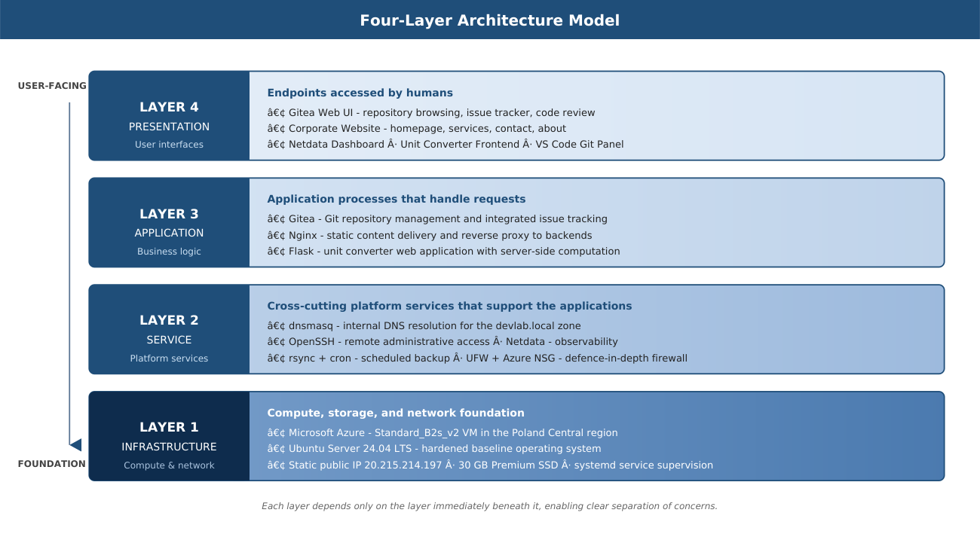
Figure 2.2 - Logical layering from infrastructure foundations up to user-facing presentation surfaces.
Figure 2.3 - Automated Nightly Backup Pipeline
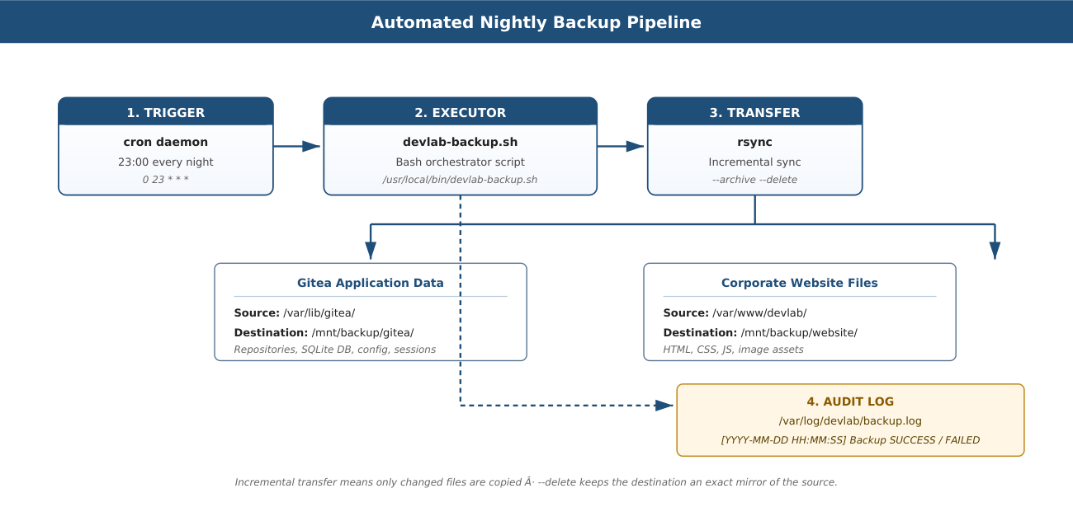
Figure 2.3 - Backup workflow: cron triggers the orchestrator script, rsync replicates two source paths, and the result is recorded in an audit log.
Figure 2.4 - Gitea Identity, Organisation and Repository Structure
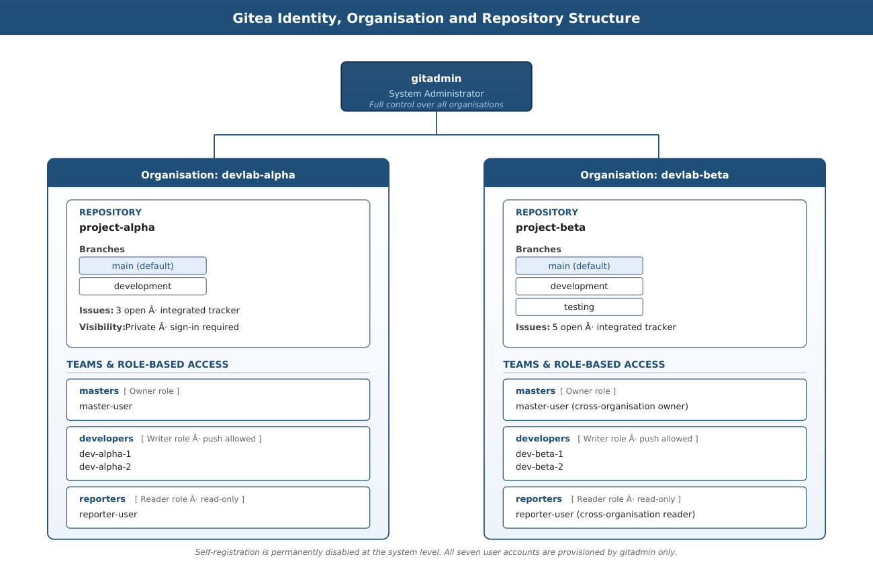
Figure 2.4 - Gitea identity model showing the gitadmin account, the two organisations, their repositories and branches, and the role-based team membership.

2.3 Network Plan
The network architecture is built around two layers of firewall protection: the Azure Network Security Group (NSG) at the cloud perimeter, and UFW (Uncomplicated Firewall) at the operating-system level. Both must permit a connection for it to reach a service. This double-layer approach provides defence-in-depth: a misconfiguration in one layer is contained by the other.

Figure 2.5 - Network Topology and Firewall Layers
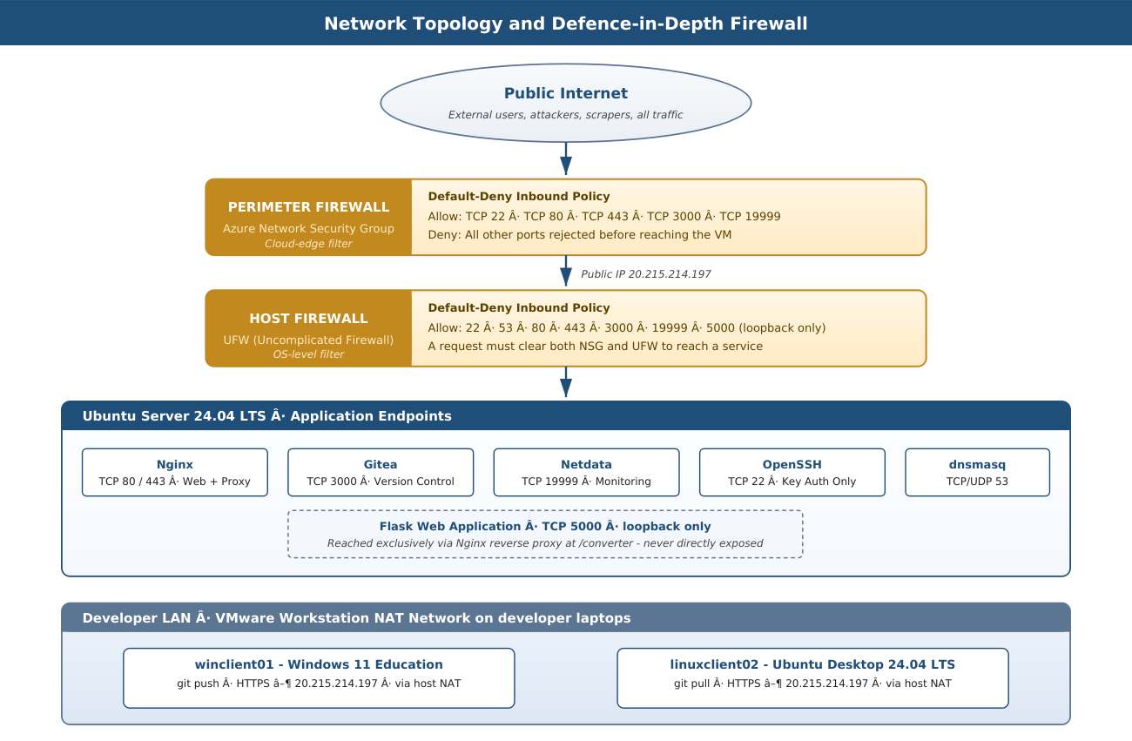
Figure 2.5 - Network topology showing both firewall layers, the application endpoints on the Ubuntu host, and the VMware NAT clients.
Port | Protocol | Service | Direction | Status
22 | TCP | SSH (remote administration) | Inbound, key auth only | Open
53 | TCP/UDP | DNS (dnsmasq) | Inbound from LAN clients | Open
80 | TCP | HTTP (auto-redirects to HTTPS) | Inbound from internet and LAN | Open
443 | TCP | HTTPS (Nginx, website, Gitea proxy) | Inbound from internet and LAN | Open
3000 | TCP | Gitea (version-control web UI) | Inbound from internet and LAN | Open
5000 | TCP | Flask app (served via Nginx proxy) | Loopback only | Internal
19999 | TCP | Netdata (monitoring dashboard) | Inbound from internet and LAN | Open
All other | Any | Default-deny inbound policy | Inbound from internet | Blocked
Table 2.10 - Firewall port plan, applied at both Azure NSG and UFW
Hostname | Type | Resolves To | Service
git.devlab.local | A | 20.215.214.197 | Gitea web UI via Nginx reverse proxy
www.devlab.local | A | 20.215.214.197 | Corporate website (Nginx)
monitor.devlab.local | A | 20.215.214.197 | Netdata monitoring dashboard
devlab.local | A | 20.215.214.197 | Root domain
Table 2.11 - DNS records for the internal devlab.local zone (dnsmasq)

2.4 Server Plan

2.4.1 Basic Information
Property | Value
Hostname | devserver
Cloud Provider | Microsoft Azure
VM Size | Standard_B2s_v2
vCPU | 2 cores
RAM | 8 GB
OS Disk | 30 GB Premium SSD
Public IP | 20.215.214.197 (Static, persistent across restarts)
Operating System | Ubuntu Server 24.04 LTS
Primary Admin User | devadmin (SSH RSA key authentication only)
Gitea Admin User | gitadmin (application-level administrator)
Table 2.12 - Server basic information

2.4.2 Services Installed
Service | Software | Port | Startup | Comment
Version Control | Gitea 1.22.3 | 3000/TCP | systemd | SQLite3 database; admin-only registration.
Web Server | Nginx 1.24+ | 80, 443/TCP | systemd | Serves website; reverse-proxies Gitea and Flask.
DNS Service | dnsmasq 2.89+ | 53/TCP+UDP | systemd | Resolves all devlab.local hostnames.
Monitoring | Netdata (latest) | 19999/TCP | systemd | Real-time CPU, RAM, disk, network dashboard.
Web Application | Python Flask 3.x | 5000/TCP | systemd | Unit converter; proxied via Nginx at /converter.
Backup | rsync + cron | n/a | cron 23:00 | Backs up Gitea data and website; writes audit log.
Remote Access | OpenSSH | 22/TCP | systemd | Key-only authentication; password login disabled.
OS Firewall | UFW | n/a | systemd | Default-deny inbound; whitelisted ports only.
Table 2.13 - Services installed on the server

2.4.3 Folder Structure
Path | Purpose
/var/lib/gitea/ | Gitea data root (all repository data, database, avatars, sessions)
/var/lib/gitea/data/repositories/ | Git repository files (project-alpha.git, project-beta.git)
/etc/gitea/app.ini | Gitea main configuration file
/var/www/devlab/ | Corporate website HTML files (index, services, contact, about)
/var/www/devlab-app/app.py | Python Flask unit-converter web-application source
/mnt/backup/gitea/ | Nightly rsync backup destination for Gitea data
/mnt/backup/website/ | Nightly rsync backup destination for website files
/var/log/devlab/backup.log | Backup execution log with timestamps and success/failure status
/usr/local/bin/devlab-backup.sh | Automated backup shell script
/etc/nginx/sites-available/devlab | Nginx virtual-host configuration
/etc/ssl/certs/devlab.crt | Self-signed TLS certificate for HTTPS
/etc/ssl/private/devlab.key | TLS private key
Table 2.14 - Server folder structure

2.5 Client Plan
Property | Client 1 - winclient01 | Client 2 - linuxclient02
Operating System | Windows 11 Education | Ubuntu Desktop 24.04 LTS
Hypervisor | VMware Workstation Pro | VMware Workstation Pro
VM vCPU | 2 cores | 2 cores
VM RAM | 4096 MB | 2048 MB
VM Disk | 40 GB | 30 GB
Network | VMware NAT | VMware NAT
Username | devadmin | devadmin
Git Client | Git for Windows 2.51.0 | Git CLI 2.43.0 (via apt)
IDE | Visual Studio Code (latest) | Visual Studio Code (via snap)
Git Identity | Rehan Khaliq / rehan@devlab.local | Danial Umer / danial@devlab.local
Git Operation | git push to development branch | git pull from development branch
Gitea Account Used | gitadmin | dev-beta-1
Table 2.15 - Client VM configuration plan

2.6 Test Plan

2.6.1 Version Control Tests
Test ID | Description | Expected Result
VCS_01 | Login to Gitea as gitadmin from a browser. | Successful (admin dashboard visible).
VCS_02 | Verify the devlab-alpha and devlab-beta organisations exist. | Successful (both organisations visible).
VCS_03 | Verify project-alpha has main and development branches. | Successful (two branches visible).
VCS_04 | Verify project-beta has main, development and testing branches. | Successful (three branches visible).
VCS_05 | Login as dev-alpha-1 and verify repository access. | Successful (project-alpha accessible).
VCS_06 | Login as reporter-user and verify read-only access. | Successful (read access confirmed; push denied).
VCS_07 | Verify three issues exist in project-alpha. | Successful (3 issues listed).
VCS_08 | Verify five issues exist in project-beta. | Successful (5 issues listed).
VCS_09 | Attempt self-registration from the browser (not logged in). | Failed (registration page does not exist).
VCS_10 | Verify master-user has access to both organisations. | Successful (Owner role on both).
Table 2.16 - Version control system test plan

2.6.2 Web Service Tests
Test ID | Description | Expected Result
WEB_01 | Access http://20.215.214.197 from a browser. | Successful (automatic redirect to HTTPS).
WEB_02 | Access https://20.215.214.197 from a browser. | Successful (DevLab homepage loads).
WEB_03 | Navigate to the Services page via the navigation menu. | Successful (services.html loads correctly).
WEB_04 | Navigate to the Contact Us page via the navigation menu. | Successful (contact.html loads correctly).
WEB_05 | Navigate to the About Us page via the navigation menu. | Successful (about.html loads correctly).
WEB_06 | Access https://20.215.214.197/converter. | Successful (unit-converter app loads).
WEB_07 | Enter 100 km and convert to miles. | Successful (server returns 62.1371 miles).
WEB_08 | Verify the HTTPS padlock is visible in the browser address bar. | Successful (TLS certificate active).
Table 2.17 - Web service test plan

2.6.3 Server Access Tests
Test ID | Description | Expected Result
SRV_01 | SSH login with the devadmin PEM key from Rehan's laptop. | Successful (shell access granted).
SRV_02 | SSH login attempt using a password (no key). | Failed (password authentication disabled).
SRV_03 | SSH login from Danial's laptop with an authorised key. | Successful (shell access granted).
SRV_04 | Check status of all services: gitea, nginx, dnsmasq, netdata, devlab-app. | Successful (all services active and running).
SRV_05 | Access the Netdata dashboard at http://20.215.214.197:19999. | Successful (live monitoring dashboard visible).
Table 2.18 - Server access test plan

2.6.4 Client Tests
Test ID | Description | Expected Result
CLI_01 | git push from winclient01 (Windows VM) to the development branch. | Successful (commits appear in Gitea development branch).
CLI_02 | git pull from linuxclient02 (Ubuntu VM) from the development branch. | Successful (latest commits downloaded; reports 'Already up to date').
CLI_03 | Verify VS Code is installed and Git integration works on the Windows VM. | Successful (Git panel visible in VS Code sidebar).
CLI_04 | Run git --version on both client VMs. | Successful (version displayed on both clients).
CLI_05 | Clone project-alpha repository from both client VMs. | Successful (repository cloned successfully on both).
Table 2.19 - Client VM test plan

2.6.5 Backup Tests
Test ID | Description | Expected Result
BCK_01 | Run the backup script manually: sudo /usr/local/bin/devlab-backup.sh. | Successful (script completes without errors).
BCK_02 | Inspect the backup log: cat /var/log/devlab/backup.log. | Successful (timestamp and SUCCESS entries visible).
BCK_03 | Verify /mnt/backup/gitea/ contains repository data. | Successful (Gitea data files and repositories present).
BCK_04 | Verify /mnt/backup/website/ contains all HTML files. | Successful (index, services, contact, about pages present).
BCK_05 | Verify cron schedule with sudo crontab -l. | Successful (0 23 * * * entry visible for devlab-backup.sh).
Table 2.20 - Backup automation test plan

3. Implementation
This section documents the complete implementation of the DevLab development environment in the order it was carried out. Each subsection covers the key commands, configuration decisions and rationale for choices made during deployment.

3.1 Cloud Infrastructure Provisioning (Microsoft Azure)
A Microsoft Azure virtual machine was provisioned using the Azure for Students subscription, which provides USD 100 of free credit on a university email address with no credit card required. The VM was deployed using Ubuntu Server 24.04 LTS with the Standard_B2s_v2 instance size.
Step | Action | Detail
1 | Create Resource Group | devlab-rg
2 | Create Virtual Machine | Ubuntu Server 24.04 LTS, Standard_B2s_v2
3 | Configure Authentication | SSH RSA public key; devlab-key.pem downloaded
4 | Set Inbound Ports | SSH (22), HTTP (80), HTTPS (443); selected during creation
5 | Set Public IP to Static | VM, Networking, IP Configuration, Static
6 | Add NSG Rules | Custom rules for ports 3000 and 19999 added after deployment
7 | Connect via SSH | ssh -i devlab-key.pem devadmin@20.215.214.197
Table 3.1 - Azure VM provisioning steps

3.2 Server Baseline Configuration
After the initial SSH connection, the server was updated and all required packages were installed in a single operation. The UFW firewall was configured with a default-deny inbound policy before any application service was started.
System update and package installation
sudo apt update && sudo apt full-upgrade -y
sudo apt install -y git curl wget nano ufw nginx dnsmasq openssl python3-flask

UFW firewall configuration
sudo ufw default deny incoming
sudo ufw default allow outgoing
sudo ufw allow 22/tcp 80/tcp 443/tcp 3000/tcp 19999/tcp 53
sudo ufw --force enable

SSH hardening (disable password authentication)
sudo nano /etc/ssh/sshd_config
# Set: PasswordAuthentication no
sudo systemctl restart ssh

3.3 Gitea (Version Control System)
Gitea was installed as a dedicated system service running under its own unprivileged user account. The binary was downloaded directly from the official Gitea releases page and registered as a systemd service for automatic startup on boot.
Installation commands
sudo adduser --system --shell /bin/bash --group --disabled-password \
--home /home/gitea gitea
sudo mkdir -p /var/lib/gitea/{custom,data,log}
sudo chown -R gitea:gitea /var/lib/gitea/
sudo mkdir -p /etc/gitea && sudo chown root:gitea /etc/gitea
sudo chmod 770 /etc/gitea
sudo wget -O /usr/local/bin/gitea \
https://dl.gitea.com/gitea/1.22.3/gitea-1.22.3-linux-amd64
sudo chmod +x /usr/local/bin/gitea

Key configuration decisions (Gitea web installer)
- Database: SQLite3, sufficient for a 3-person team and avoiding the need for a separate database server.
- Self-registration: DISABLED. Only the gitadmin role can create user accounts.
- Sign-in required to view pages: ENABLED. Anonymous browsing is not permitted.
- Admin account: gitadmin / admin@devlab.local.
Gitea user and organisation structure
Two organisations (devlab-alpha, devlab-beta) and two repositories (project-alpha, project-beta) were created through the Gitea web UI. Seven user accounts were created and assigned to organisation teams with role-based permissions, as specified in the requirements.

3.4 Nginx (Web Server and Reverse Proxy)
Nginx was configured with three server blocks: one for the corporate website and two for reverse-proxying Gitea and the Flask application. HTTP traffic on port 80 is permanently redirected to HTTPS on port 443.
sudo nano /etc/nginx/sites-available/devlab

# server { listen 80; return 301 https://$host$request_uri; }
# server { listen 443 ssl; root /var/www/devlab; ssl_certificate ...; }
# location /git/ { proxy_pass http://127.0.0.1:3000/; }
# location /converter { proxy_pass http://127.0.0.1:5000/converter; }

sudo ln -s /etc/nginx/sites-available/devlab /etc/nginx/sites-enabled/
sudo nginx -t && sudo systemctl reload nginx

3.5 TLS Certificate (HTTPS)
A self-signed RSA 2048-bit TLS certificate was generated using OpenSSL. The certificate is valid for 365 days and is configured for the server's public IP address. Browser clients will display a certificate warning that must be acknowledged on first visit; this is the expected behaviour for a self-signed certificate in a non-public-facing pilot deployment.
sudo openssl req -x509 -nodes -days 365 -newkey rsa:2048 \
-keyout /etc/ssl/private/devlab.key \
-out /etc/ssl/certs/devlab.crt \
-subj "/C=HU/ST=Budapest/O=DevLab/CN=20.215.214.197"

3.6 Corporate Website
The DevLab corporate website consists of four pages built with HTML5 and CSS3, served by Nginx from /var/www/devlab/. The website features a consistent navigation menu across all pages linking to the four required sections.
Page | File | Content
Homepage | index.html | Company news, summary of activities, three news cards (project launch, team expansion, open source).
Services | services.html | Four service offerings: web development, version control, server administration, DevOps automation.
Contact Us | contact.html | Email, phone, address (Obuda University, Budapest), working hours.
About Us | about.html | Company description, team-member profiles for all three developers with roles.
Table 3.2 - Corporate website pages

3.7 Flask Web Application
A Python Flask web application was developed to demonstrate server-side computation. The application implements a unit converter that accepts a numeric value and a conversion type via HTTP POST, performs the mathematical conversion on the server, and returns the result as JSON. The frontend communicates with the server asynchronously using the Fetch API.
Conversion | Formula | Example Input | Example Output
Kilometres to Miles | km × 0.621371 | 100 km | 62.1371 miles
Miles to Kilometres | mi × 1.60934 | 100 miles | 160.934 km
Celsius to Fahrenheit | (°C × 9/5) + 32 | 100 °C | 212 °F
Fahrenheit to Celsius | (°F − 32) × 5/9 | 212 °F | 100 °C
Kilograms to Pounds | kg × 2.20462 | 70 kg | 154.323 lbs
Pounds to Kilograms | lbs × 0.453592 | 154 lbs | 69.853 kg
Metres to Feet | m × 3.28084 | 10 m | 32.808 ft
Feet to Metres | ft × 0.3048 | 100 ft | 30.48 m
Table 3.3 - Unit-converter supported conversions
Flask application service registration
sudo nano /etc/systemd/system/devlab-app.service

# [Service]
# ExecStart=/usr/bin/python3 /var/www/devlab-app/app.py

sudo systemctl enable devlab-app
sudo systemctl start devlab-app

3.8 dnsmasq (Internal DNS)
dnsmasq was configured to resolve all devlab.local hostnames to the server's public IP address. Google DNS (8.8.8.8) was specified as the upstream resolver for all external domain lookups. The service is bound to the server's primary network interface.
sudo nano /etc/dnsmasq.conf

# domain=devlab.local
# address=/git.devlab.local/20.215.214.197
# address=/www.devlab.local/20.215.214.197
# address=/monitor.devlab.local/20.215.214.197
# server=8.8.8.8

sudo systemctl restart dnsmasq
sudo systemctl enable dnsmasq

3.9 Netdata (Monitoring)
Netdata was installed from the Ubuntu apt repository with a single command. On installation, Netdata automatically detects and begins monitoring all hardware resources without further configuration. The dashboard updates with one-second granularity.
sudo apt install netdata -y
sudo systemctl start netdata
sudo systemctl enable netdata

- CPU monitoring: real-time utilisation per core, with system / user / idle breakdown.
- Memory monitoring: used, free, cached and buffered RAM, plus swap usage.
- Disk I/O monitoring: read and write throughput and latency per device.
- Network monitoring: inbound and outbound bytes per second per interface.
- Process monitoring: per-process CPU and memory consumption.
- Dashboard accessible at http://20.215.214.197:19999.

3.10 Backup Automation
The backup script was written in Bash and deployed to /usr/local/bin/devlab-backup.sh. The script uses rsync with the --delete flag to perform incremental synchronisation. A cron job runs the script automatically at 23:00 every night. The script backs up both the Gitea repository data and the website files, and writes a detailed log entry for every execution.
Backup script structure
#!/bin/bash
DATE=$(date '+%Y-%m-%d %H:%M:%S')
echo "[$DATE] DevLab backup started" >> /var/log/devlab/backup.log
rsync -av --delete /var/lib/gitea/ /mnt/backup/gitea/ >> backup.log 2>&1
rsync -av --delete /var/www/devlab/ /mnt/backup/website/ >> backup.log 2>&1
echo "[$DATE] Backup completed" >> /var/log/devlab/backup.log

Cron schedule
sudo crontab -e
0 23 * * * /usr/local/bin/devlab-backup.sh

3.11 Client Virtual Machines (VMware Workstation Pro)
Two developer client virtual machines were created in VMware Workstation Pro running on a developer's personal Windows laptop. Both VMs use VMware NAT networking, which provides internet access through the host machine's connection and allows direct communication with the Azure server at 20.215.214.197.
Setting | winclient01 (Windows 11) | linuxclient02 (Ubuntu Desktop)
VM ID / Name | winclient01 | linuxclient02
ISO Used | Windows 11 Education (university licence) | Ubuntu Desktop 24.04 LTS (free)
Disk | 40 GB | 30 GB
CPU | 2 cores | 2 cores
RAM | 4096 MB | 2048 MB
Network | VMware NAT | VMware NAT
Git Version | 2.51.0.windows.1 | 2.43.0
Git Push Result | Successful (vm-test.txt pushed to development branch) | n/a (pull only)
Git Pull Result | n/a (push only) | Successful (Already up to date)
VS Code | Installed via winget | Installed via snap
Table 3.4 - Client VM configuration and verification results
Windows 11 VM key post-install commands
winget install Git.Git --source winget
winget install Microsoft.VisualStudioCode --source winget
git config --global user.name "Rehan Khaliq"
git config --global user.email "rehan@devlab.local"
git clone http://20.215.214.197:3000/devlab-alpha/project-alpha.git
git checkout development && git push origin development

Ubuntu Desktop VM key post-install commands
sudo apt install git -y && sudo snap install code --classic
git config --global user.name "Danial Umer"
git config --global user.email "danial@devlab.local"
git clone http://20.215.214.197:3000/devlab-alpha/project-alpha.git
git checkout development && git pull origin development

4. Testing
All tests were executed by team members between 13 and 19 April 2026. Results were recorded immediately after each test was performed. Screenshots were captured as evidence for each passing test.

4.1 Version Control Tests
Test ID | Description | Expected | Date | Result
VCS_01 | Login to Gitea as gitadmin from a browser. | Successful | Apr 13, 2026 | Successful
VCS_02 | Verify devlab-alpha and devlab-beta organisations exist. | Successful | Apr 13, 2026 | Successful
VCS_03 | Verify project-alpha has main and development branches. | Successful | Apr 13, 2026 | Successful
VCS_04 | Verify project-beta has main, development and testing branches. | Successful | Apr 13, 2026 | Successful
VCS_05 | Login as dev-alpha-1 and verify project-alpha access. | Successful | Apr 13, 2026 | Successful
VCS_06 | Login as reporter-user and verify read-only access. | Successful | Apr 13, 2026 | Successful
VCS_07 | Verify three issues exist in project-alpha. | Successful | Apr 13, 2026 | Successful
VCS_08 | Verify five issues exist in project-beta. | Successful | Apr 13, 2026 | Successful
VCS_09 | Attempt self-registration from the browser. | Failed (expected) | Apr 13, 2026 | Failed (correct)
VCS_10 | Verify master-user is Owner of both organisations. | Successful | Apr 13, 2026 | Successful
Table 4.1 - Version control system test results

4.2 Web Service Tests
Test ID | Description | Expected | Date | Result
WEB_01 | Access http://20.215.214.197 (verify HTTPS redirect). | 301 Redirect | Apr 13, 2026 | Successful
WEB_02 | Access https://20.215.214.197 (homepage loads). | Successful | Apr 13, 2026 | Successful
WEB_03 | Navigate to the Services page via the menu. | Successful | Apr 13, 2026 | Successful
WEB_04 | Navigate to the Contact Us page via the menu. | Successful | Apr 13, 2026 | Successful
WEB_05 | Navigate to the About Us page via the menu. | Successful | Apr 13, 2026 | Successful
WEB_06 | Access https://20.215.214.197/converter. | Successful | Apr 13, 2026 | Successful
WEB_07 | Enter 100 km, convert to miles, verify server result. | 62.1371 miles | Apr 13, 2026 | 62.1371 miles
WEB_08 | Verify the HTTPS padlock is visible in the address bar. | Padlock visible | Apr 13, 2026 | Successful
Table 4.2 - Web service test results

4.3 Server Access Tests
Test ID | Description | Expected | Date | Result
SRV_01 | SSH login with PEM key from Rehan's laptop. | Successful | Apr 13, 2026 | Successful
SRV_02 | SSH login attempt with password authentication. | Failed (expected) | Apr 13, 2026 | Failed (correct)
SRV_03 | SSH login from Danial's laptop with authorised key. | Successful | Apr 13, 2026 | Successful
SRV_04 | Check status of all services: gitea, nginx, dnsmasq, netdata, devlab-app. | All active | Apr 13, 2026 | All active and running
SRV_05 | Access Netdata at http://20.215.214.197:19999. | Dashboard visible | Apr 13, 2026 | Successful (live graphs visible)
Table 4.3 - Server access test results

4.4 Client Tests
Test ID | Description | Expected | Date | Result
CLI_01 | git push from winclient01 to the development branch. | Successful | Apr 19, 2026 | Successful (vm-test.txt visible in Gitea)
CLI_02 | git pull from linuxclient02 from the development branch. | Successful | Apr 19, 2026 | Successful (Already up to date)
CLI_03 | VS Code installed with Git integration on the Windows VM. | Successful | Apr 19, 2026 | Successful
CLI_04 | git --version on the Windows VM. | Shows version | Apr 19, 2026 | git version 2.51.0.windows.1
CLI_05 | git --version on the Ubuntu VM. | Shows version | Apr 19, 2026 | git version 2.43.0
CLI_06 | Clone project-alpha from both VMs. | Successful | Apr 19, 2026 | Successful on both VMs
Table 4.4 - Client VM test results

4.5 Backup Tests
Test ID | Description | Expected | Date | Result
BCK_01 | Run the backup script manually on the server. | No errors | Apr 13, 2026 | Successful (no errors)
BCK_02 | Inspect the backup log: timestamp and SUCCESS entries. | Success entries | Apr 13, 2026 | Successful (entries confirmed)
BCK_03 | Verify /mnt/backup/gitea/ contains repository data. | Files present | Apr 13, 2026 | Successful (all repositories backed up)
BCK_04 | Verify /mnt/backup/website/ has all four HTML files. | 4 HTML files | Apr 13, 2026 | Successful (all pages backed up)
BCK_05 | Verify cron schedule with sudo crontab -l. | 0 23 * * * entry | Apr 13, 2026 | Successful (schedule confirmed)
Table 4.5 - Backup automation test results

All requirements documented in section 1.3 have been fully implemented and verified. Both client VMs, Windows 11 Education and Ubuntu Desktop 24.04, were confirmed to communicate successfully with the Gitea server hosted on Microsoft Azure.

End of Document
DevLab Development Environment & Web Service | Task 3 | Spring 2025/2026
Rehan Khaliq · Shah Nawaz · Danial Umer | Obuda University

